NAME :SAMMY EDYSON NDERITU
REG.NO: 24/01848
OBJECT ORIENTED PROGRAMMING.

- Banking Application – Balance Calculator Write a function double computeBalance(double deposit, double withdrawal) that calculates and returns the final balance after a deposit and withdrawal. In main(), allow the user to input the deposit and withdrawal amounts, call the function, and display the final balance.
- Temperature Converter Create a function float toCelsius(float fahrenheit) that converts a temperature from Fahrenheit to Celsius. Use main() to get the temperature from the user, call the function, and display the result.
- Grading System Write a function char getGrade(int score) that returns a grade based on the score: - 80–100: 'A' - 60–79: 'B' - 40–59: 'C' - Below 40: 'F' In main(), ask the user to input a score and display the corresponding grade.

Answers
Balance calculator.
#include <iostream>
using namespace std;
// Function that displays the balance
double computeBalance(double deposit, double withdrawal) {
return deposit - withdrawal;
}
int main(int argc, char** argv) {
double deposit, withdrawal;
cout << "Enter the deposit amount: ";
cin >> deposit;
cout << "Enter the withdrawal amount: ";
cin >> withdrawal;
double finalBalance = computeBalance(deposit, withdrawal);
cout << "The final balance is: " << finalBalance << endl;
return 0;
}

Output
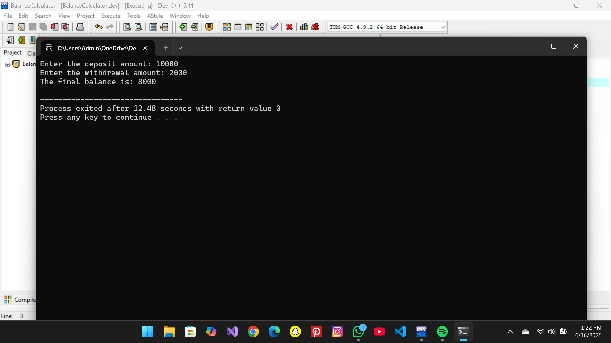

Temperature Function
Code:
#include <iostream>
using namespace std;
// Here the fuction converts Farenheit to Temperature in Celcius
float toCelsius(float fahrenheit) {
return (fahrenheit - 32) * 5 / 9;
}
int main() {
float fahrenheit;
cout << "Enter temperature in Fahrenheit: ";
cin >> fahrenheit;
float celsius = toCelsius(fahrenheit);
//Result
cout << "Temperature in Celsius: " << celsius << endl;
return 0;
}
Output
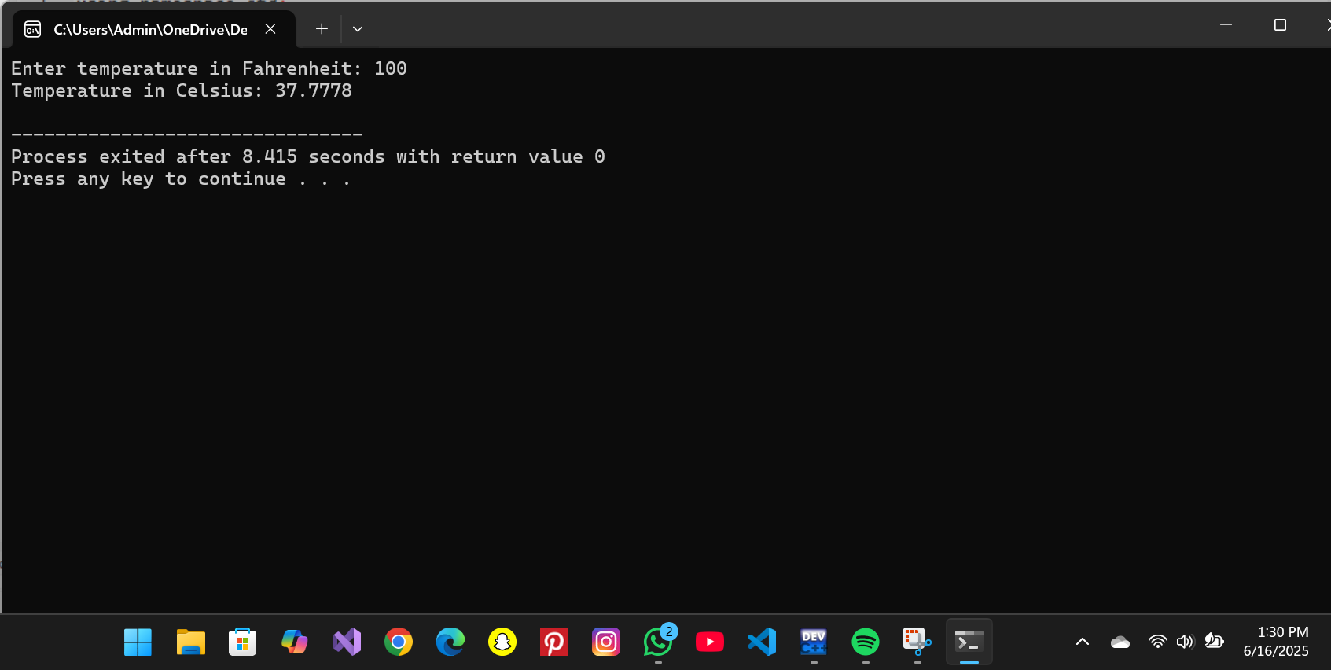

Grades
Code.
#include <iostream>
using namespace std;
char getGrade(int score) {
if (score >= 80 && score <= 100) {
return 'A';
} else if (score >= 60 && score <= 79) {
return 'B';
} else if (score >= 40 && score <= 59) {
return 'C';
} else {
return 'F';
}
}
//Main Function
int main(int argc, char** argv) {
int score;
cout << "Enter the score: ";
cin >> score;
char grade = getGrade(score);
cout << "The grade is: " << grade << endl;
return 0;
}
Output:
